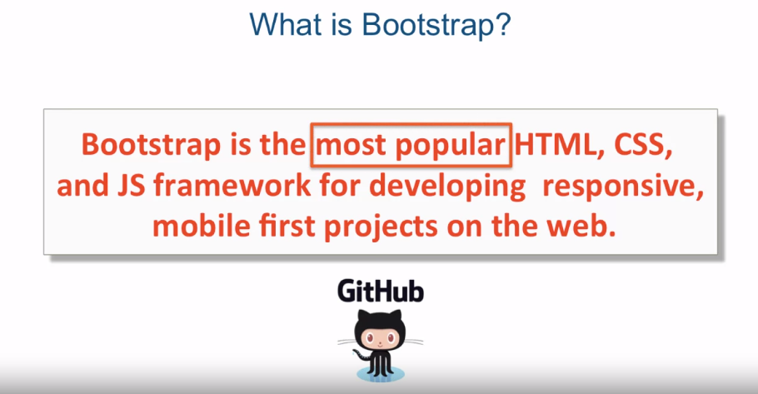

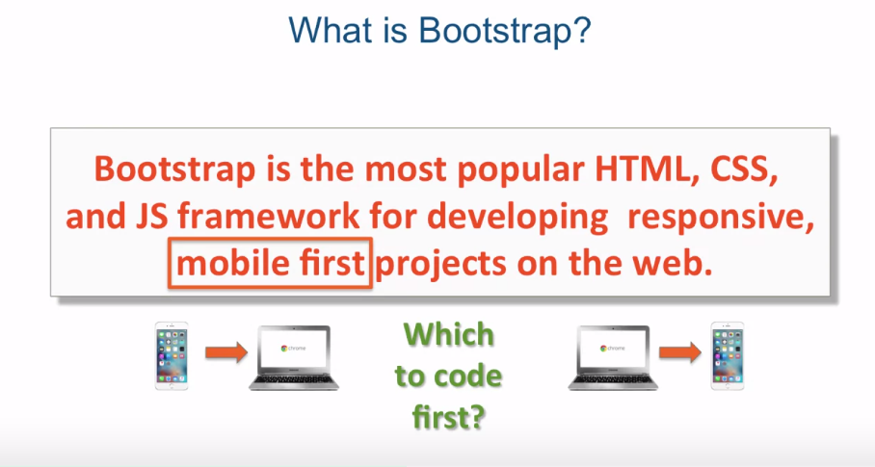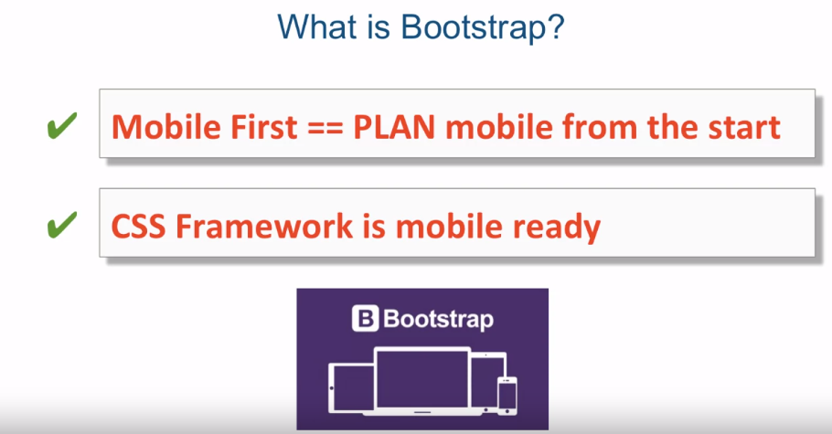

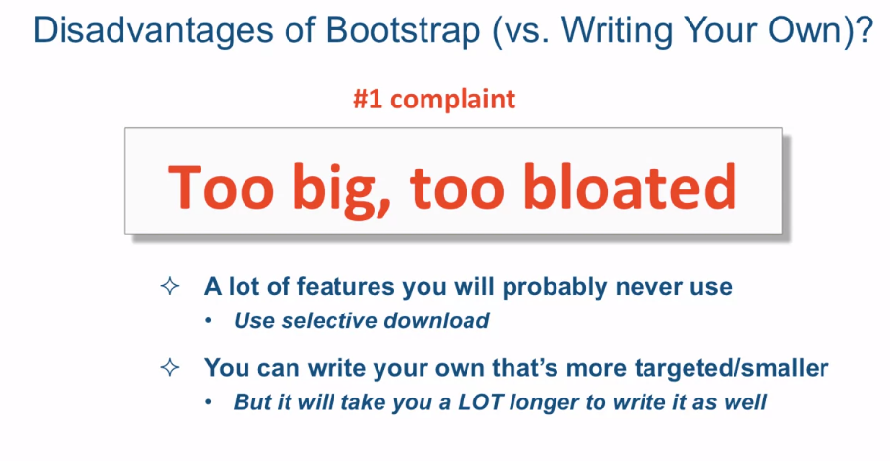

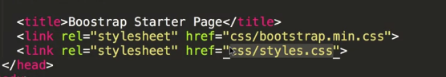

[MUSIC] In this lecture we're going to start

introducing Bootstrap which is a CSS framework. One of the most popular CSS frameworks

which was made by the engineers at Twitter. Now what is Bootstrap? Well, Bootstrap is the most popular HTML,

CSS, and JavaScript framework for developing responsive,

mobile first projects on the web. And this is a direct quote

from the Bootstrap website. Let's take it apart a little bit. First of all,

it's the most popular framework. While GitHub, which is basically

a large website with code repository that has a social component to it,

has over 90,000 stars or likes of the Bootstrap project. So it's the most popular

project on the entire website. And it's been forked over 38,000 times. Bootstrap consists mostly of CSS. It pre-defines a lot of CSS classes for

you. So you know, a lot of the times, especially with a user interface that's

a bit more complex than just a single HTML element or something, CSS needs

to target a certain HTML structure. Well because of that reason,

Bootstrap often times requires you to have a particular HTML structure

in your HTML page. In practice, however,

it's not as scary as that sounds. It doesn't really invade

your HTML code and make you write some crazy HTML constructs. It just asks you to add

an extra div here and there and give it a particular class so that the CSS

Bootstrap defined would apply properly. Its JavaScript framework

shouldn't be overlooked either. It has a very cool JavaScript framework

actually based on the J Query APIs and plugin architecture that lets you put in,

and lets others put in, different plugins that

really enhance your website quite a bit. Bootstrap is also called

a mobile first framework. Now what does it mean? Well in general, the term means that you

deal with how your user interface is laid out on the mobile device first. In the reality from what I've seen, there

are two approaches to what this means. There's the purist approach, which says

you code your mobile version first. And the claim is that it really

helps your content strategy. How are you going to lay out your content,

what the content should be. It really forces you to think, what's really important in your

content that you're about to present. There's also a second approach

to what mobile first means. And I will call that not

100% purist approach. And I kind of count myself among

that type of thinking group. So the idea there is that you plan for

mobile in your styles. But you can start coding with

desktop version first, if it feels more comfortable for you, or if it

just makes more sense for your project. I can just feel all of

the user experience pure so in the beginning upset at me for

saying that. Well. So as far as coding is concerned, I would say either approach starting

from mobile and going to desktop or starting from desktop and going to

mobile are really two valid approaches. However, everybody will agree on this, that mobile first definitely means is

that you plan for mobile from the start. You don't ignore it until the end or

the middle of your project. You plan for it from the start. And they also agree that CSS framework,

whether written by you or you take something like Bootstrap,

should be mobile already. And what that means is is that it

shouldn't be again an afterthought. Where after you set up your desktop

version somehow you have to write some or include some other CSS that would now

kind of magically try to turn this, the entire website into this

mobile website as well. And interestingly enough, Bootstrap

wasn't always a mobile first framework. It used to be, I forgot which version that

was already, I think maybe 2 or something like that, that Bootstrap had a separate

CSS file and separate set of classes. If you wanted your website

to be responsive or be basically be able to be viewed

on mobile devices as well. But nowadays,

Bootstrap is a mobile first framework. So are there any disadvantages

of using Bootstrap versus for example writing your own,

like we did with the previous lecture. Well the number one complaint, the disadvantage of bootstrap,

is that it's too big and it's too bloated. And what that means is there's a lot of

features in there that you will probably never use. Well, the mitigating factor is you could

use selective download on the Bootstrap website and only download the features

you actually think you will use. But the truth of the matter is even

though it is a little bit too bloated, It's not really that bad. And the claim also is that

you could write your own framework that's more targeted and

therefore much smaller. Well, that may be true, but

it will take you a lot longer to write it. And certainly take you a lot

longer to write it just as well as the guys at Twitter did. Which they put a lot of thought and a lot

of painstaking decisions into every little turn that you'll probably just not have

the time and the bandwidth to deal with. In part two of this lecture, let's jump

into the code editor and take a look at what a basic barebones HTML document

looks like and how to properly set it up.